1001 Arabian nights
This frame story for the entirety of the work is the common thread between each edition of Nights. Shahryar is a king who rules over India and China. He becomes aware of his wife’s infidelity and has her executed, and afterward, in anger and sadness, decides all women are guilty and must be executed. Shahryar marries and executes several virgins, each on the morning after they are married. When the king takes Scheherazade as his wife, she tells him a story on the night of their marriage, but she doesn’t have time to finish it. The king postpones her execution to find out the end of the story. The next night she finishes her story but begins a new one, and Shahryar postpones her execution again. They continue this for 1,001 nights.

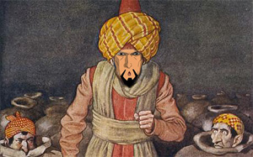
Ali Baba and the Forty Thieves
Ali Baba, a poor woodcutter was in the forest when he saw forty thieves stop in front of a cave.

The leader said “Open Sesame!” and before Ali Baba’s amazed eyes the sealed mouth of the cave magically opened and the men disappeared inside. To come out and close the entrance, the leader said “Close Sesame” and the cave sealed itself once more. Trembling with excitement Ali Baba waited till the thieves had left and then entered the cave after saying the magic words. To his delight he found lots of treasure.

Ali Baba told his brother Kasim about the wondrous cave. Kasim set off to get some treasure for himself too. Sadly, he forgot the words to leave the cave and the thieves killed him. Ali Baba discovered his brother’s body in the cave. With the help of a slave girl called Morgiana, he was able to take Kasim’s body back home and bury it.

Realising that someone else knew about their cave, the thieves tracked Ali Baba down. The leader, disguised as an oil seller stayed with Ali Baba. He had brought along mules loaded with forty oil jars containing the other thieves. Clever Morgiana knew who the oil seller really was and poured boiling oil into the jars killing the other thieves. While dancing in front of the leader of the thieves Morgiana stabbed him. Ali Baba was saved and lived happily ever after.

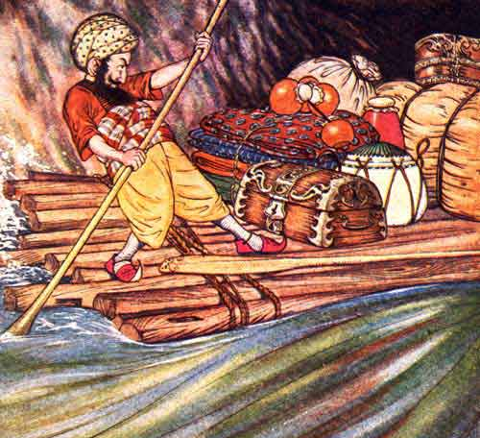
Sindbad and His Seven Voyages
Long-long ago during the reign of Caliph Harun-Al-Rashid, there lived a poor porter in the city of Baghdad. The porter’s name was Hindbad. Despite his hard life, he was happy and satisfied.

One day, Hindbad was going with a big load on his head. Suddenly the rain lashed and Hindbad rushed to a nearby house to take shelter. It was a sprawling beautiful house. Hindbad sat in a shed and waited for the rain to stop. While sitting there, he was enchanted by the soft melodious music and the rich soothing fragrance of perfume coming from inside.

The beautiful house and its visible luxury caused a tinge of sadness in the heart of the poor porter. He exclaimed loudly, “Why am I poor and why do I lead such a hard life? Whereas, a few others are rolling in the wealth. Why is this discrepancy? Am I not a good person?”

The owner of the house, whose name was Sindbad, overheard the poor porter’s disappointed utterances. He at once sent his servant to call Hindbad inside. When the porter came in, Sindbad offered him a seat with a kind smile.

The house was much more luxurious from inside. Sindbad offered rich meal to the poor porter. After the meal, Sindbad asked pointedly, “Now tell me, why were you expressing resentment at your fate?”

“Sir, when I saw your splendid life, I felt dejected. My poor fate annoyed me and so I expressed my resentment,” said Hindbad.

Sindbad said, “You have every right to think like this at this moment. However, I would like to tell you the story of my adventurous life. The dangers I faced during my bold and dreaded acts. The gravest risk I undertook to earn so much of wealth.”

Sindbad then narrated to Hindbad his various adventurous trips through which he could heap up enormous wealth.

Sinbad's First Voyage
Sinbad had inherited much wealth from his parents, but he spent it quickly due to poor, youthful decisions. Without any money, he set off to sea as a merchant sailor. He quickly grew accustomed to the sea, and began to make money at various ports.

One day, the ship docked on an island, and the sailors made a fire, only to discover that they were actually on the back of a whale. As the fire started burning, the whale dove deep into the ocean, leaving Sinbad floundering on a piece of wood as his ship fled without him. He was stranded in the middle of the sea.

Eventually, he drifted onto an island. There, he helped a horsegroom to save a mare from being drowned by a mystical, powerful sea horse. He then learned that the horsegroom served King Mihrage, who ruled the island. The horsegroom gladly brought the sailor to meet Mihrage.

The king graciously received Sinbad, giving him everything he needed. Sinbad befriended other merchants and sailors on the island, so he was in a position to recognize a chest with his name on it when a ship docked on the island one day. He quickly realized that this was the very ship that had left him. Sinbad's captain initially doubted the sailor's claim - they all believed Sinbad had drowned - but was eventually convinced.

Before leaving the island, Sinbad gave King Mihrage some of his rediscovered belongings as gifts, and the king bestowed him with valuable gifts in return. During the ship's return to Baghdad, Sinbad progressively traded these gifts for items of more value, so that he was incredibly wealthy when he arrived home.

After finishing the story of his first voyage, Sinbad gives the porter some money to take back to his family, and bids him return the following night to hear more.

Why does Sheherazade tell the stories each night? What does it tell you about Arabian culture that he has many wives and is able to kill them all to exact his revenge?

What do you think the values are in these societies based on the story’s morals? Site-specific text evidence to back up your claim. (Write down at least three values).

How does the “rags to riches” theme show up in both stories? This is a common theme throughout many of the 1001 Arabian Nights stories. Why do you think going from poor to rich is a common theme?

Have you ever heard about any of these stories or anything from these stories before? Would it surprise you to hear that the story of Aladdin is from this book, as well?

