African Colonization – Notes 4/20/17
Read pgs. 542-543

You will be responsible for knowing the content on these pages. We only took a few notes on these pages, so make sure you read it well and understand the concepts for the exam.

Apartheid – an official government policy of keeping white and black South Africans apart
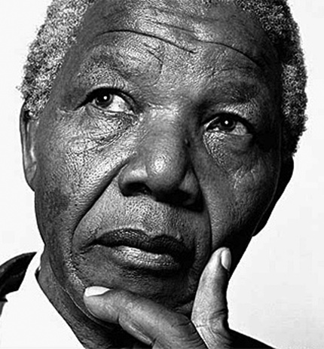
Nelson Mandela (1918 – 2013)
- The first black, South African president
- Was leader of the ANC (African National Congress) in the 1950s to end apartheid
- Imprisoned in 1962 for “sabotage and conspiracy to overthrow the state” – which means that he supposedly planned to overthrow the current government in South Africa
- He was sentenced to life imprisonment at the age of 44 to Robben Island Prison to work hard labor
- Mandela was released in 1990 after negotiating with the opposing parties secretly to end apartheid
- F.W. de Klerk, the president of South Africa at the time, worked along side Mandela to end apartheid
- Mandela used rugby to get some Afrikans (white South Africans) on his side – the Rugby World Cup in 1995 was hosted and won by the South Afrikans team

African Colonization – Notes 4/20/17
Read pgs. 542-543

You will be responsible for knowing the content on these pages. We only took a few notes on these pages, so make sure you read it well and understand the concepts for the exam.

Apartheid – an official government policy of keeping white and black South Africans apart
Nelson Mandela (1918 – 2013)
- The first black, South African president
- Was leader of the ANC (African National Congress) in the 1950s to end apartheid
- Imprisoned in 1962 for “sabotage and conspiracy to overthrow the state” – which means that he supposedly planned to overthrow the current government in South Africa
- He was sentenced to life imprisonment at the age of 44 to Robben Island Prison to work hard labor
- Mandela was released in 1990 after negotiating with the opposing parties secretly to end apartheid
- F.W. de Klerk, the president of South Africa at the time, worked along side Mandela to end apartheid
- Mandela used rugby to get some Afrikans (white South Africans) on his side – the Rugby World Cup in 1995 was hosted and won by the South Afrikans team

