African Colonization Notes
Read pg. 515, 540-541, 568-589

West and Central Africa
- Began trading with Africans around the late 1400s.
- Similar to Arabs, they were looking for gold.
- Europeans soon became involved in the slave trade. Trading slaves was not a new concept in Africa and had been used in the trans-Saharan trade for quite some time.

The Atlantic Slave Trade
- In the 1500s, the Europeans began colonizing the Americas. As a result, they needed more cheap labor to farm and began to transport enslaved Africans across the Atlantic Ocean to America. These slaves worked on colonial plantations to help farm cotton, tobacco, and other cash crops.

- The triangular trade was a trade system in which (1)African traders sold slaves for (2) manufactured goods from Europe, such as cloth and guns and transported slaves to the Americas to work on plantations. (3) The Americas gave textiles and cash crops to Europe (sugar cane, tobacco and cotton).

- The "middle passage" is the awful, deathly voyage across the Atlantic on which many MANY slaves died or became ill. The treatment of slaves was despicable and gruesome.
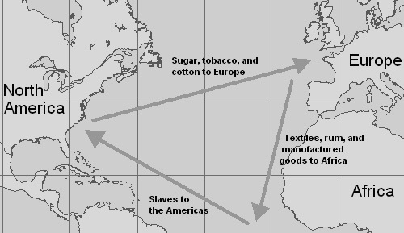

Effects of the Trade
1. The Atlantic slave trade was the largest forced migration in history!
2. The slave trade changed the relationship between African states in the region.
3. Stronger states attacked weaker ones to get slaves to trade.
4. Africans who went to the Americas brought their culture with them, which influenced the cultures in those areas.

Colonialism
- Slavery was outlawed in the U.S. and Europe by the early 1800s, but Europeans continued to interfere in African life.

- In the late 1800s., European countries began to look for colonies to claim in Africa.

- "Colonialism": a policy in which one country looks to rule other ares.

- "Imperialism": the policy of creating an empire by taking over other areas

- Europeans countries had colonized almost all of Africa by 1900.

Southern and Eastern Africa
- 1400s - Europeans began traveling to Southern and Eastern Africa in search for trade first and later to colonize.

- Portuguese took control of parts of Eastern Africa because they wanted to control the slave trade along the coast.

- The Africans in this region also suffered from the trans-Atlantic slave trade, as well. This made them weak and vulnerable to the pressure of European empires.

- 1800s - Europeans traveled and conquered territory in Southern and Eastern Africa.

- 1900s - European nations ruled most of Africa

Trading Companies
- Trading companies were responsible for founding many of the European colonies in Africa. These companies needed to send supplies to traders traveling to Asia. They sent settlers to build supply posts.

- One famous town colonized for trade was known as Cape Town in South Africa. The Dutch East India Company settled this colony as well as Cape Colony.

Boers
- Farmers from the Netherlands, France, and other European nations. "Boers" is Dutch for "farmers".

- Gold and diamonds were found in the region, which helped to bring many more Europeans to the area. Britain took the colony from the Dutch in 1795. Britain also colonized Kenya and Zimbabwe.

