Religion in Europe
Christianity:

Denomination:

THE BIRTH OF CHRISTIANITY
Abraham, Noah and Moses

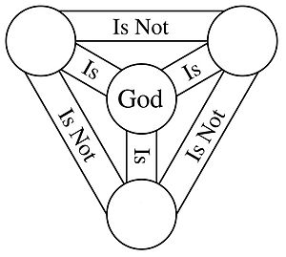
Jesus Christ

Bible

Power of the Church
- Money

- Viewed the local priest as a passport to heaven

- Power to kick people out of the church
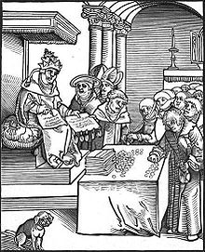
1517 – Luther and the 95 Theses
Martin Luther:

Indulgences:
MONEY = forgiveness of sins and less time
In purgatory (you could go to
Heaven sooner)

95 Theses - Main Points:
- Selling indulgences to finance the building of St. Peter’s is wrong.
- The pope has no power over Purgatory.
- Buying indulgences gives people a false sense of security and endangers their salvation.

Purgatory
(in Roman Catholic doctrine) a place or state of suffering inhabited by the souls of sinners who are expiating their sins before going to heaven.

**Starts the separation from Catholic Church into different denominations of Christianity
ex. like Lutherans, Protestants, Episcopalians, Methodists, etc.

What are saints?

